Requirement Analysis
Data Flow Diagram & User Stories
Date | 5 September 2026
Student Name | Bantupalli Niharika
Project Name | Automated Network Request Management
Maximum Marks

Logical Data Flow
Step | Flow
1 | Employee opens the Service Portal.
2 | Selects the Network Request catalog item.
3 | The catalog item opens the Network Request form.
4 | Employee enters the required network request information.
5 | Catalog UI Policies and validations display relevant fields and validate the form.
6 | Employee submits the Network Request, creating the REQ/RITM and request record.
7 | Flow Designer processes the request and sends it for approval.
8 | After approval, a Network Task is created and assigned to the Network Fulfillment Team.
9 | The Network Team processes and completes the request.

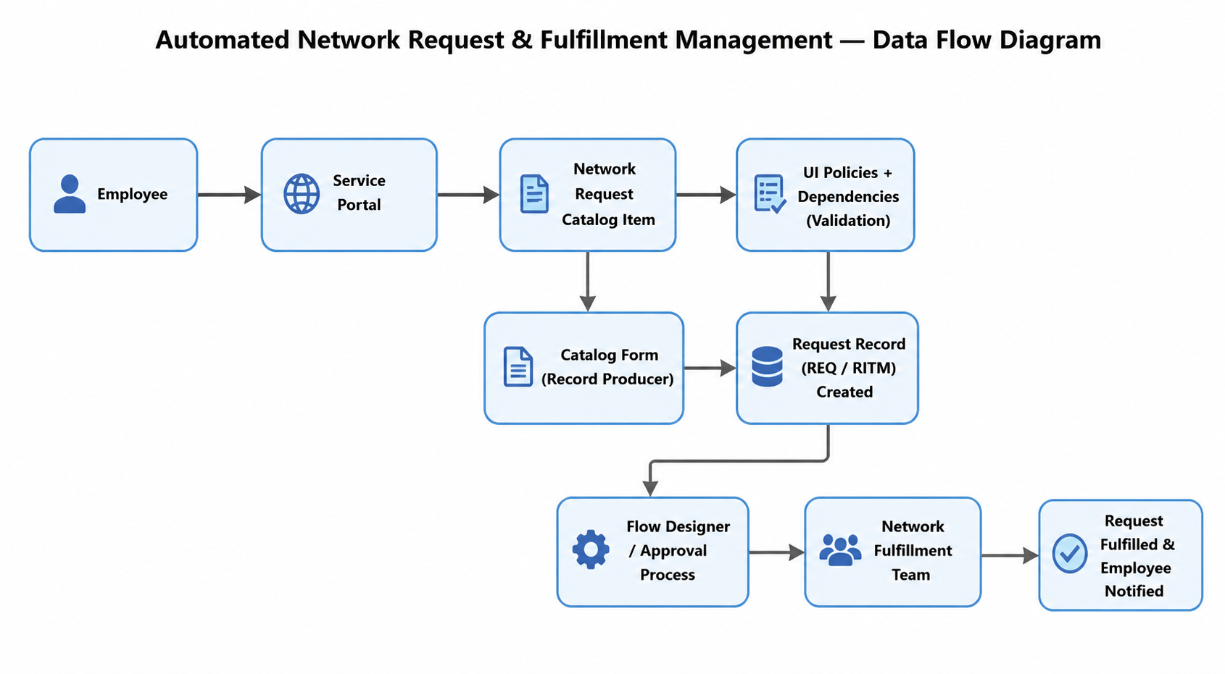
Flow: Employee → Network Request → Approval → Network Team → Request Completed
Figure 1: High-level Automated Network Request Management Data Flow.
User Stories
User Type | User Story | Acceptance Criteria | Priority
Employee | Find Network Request. | Item visible. | High
Employee | Enter request details. | Variables available. | High
Employee | Submit request. | Request created. | High
Approver | Approve request. | Approval works. | High
Network Team | Complete request. | Task assigned. | High
Admin | Maintain configuration. | Editable. | Medium

